Strategies to Determine a Product
Subject: Mathematics Creator: Alison Kimbley
Stand: Number Grade: 4
Content (topic)

Exploring Multiplication and Products
Outcomes  N 4.3: Demonstrate an understanding of multiplication of whole numbers limited to numbers less than or equal to 10 by:  - Applying mental mathematics strategies  - Explaining the results of multiplying by 0 and 1 | Indicators  N 4.3a: Explain the strategy used to determine a product  N 4.3b: Explain the strategy used in a given solution to a product  N 4.3c: Explain the property for determining the answer when multiplying by one.
Mathematical Processes:
- Communication
- Connections
- Reasoning
Lesson Preparation
Equipment/materials:
- One centimeter graph paper
- A loom
- A set of pony beads
- Wool
- Markers/pencil crayons
Advanced Preparation:
- *Instructions for making a loom*
- If possible, prepare a loom to have four or more rows with a specified pattern.
Presentation
Development
- Teach the students about the significance of beads. For example, beading has been an important part of First Nations culture for approximately 8 000 years prior to European contact. Beads were made of shell, pearl, bone, teeth, stone, and fossil stems. Glass beads became a part of First Nation and Métis culture when the explorers came from Europe and brought seed and glass beads as trading items.
- Explain to students that each tribe had distinct designs, patterns, and approaches; therefore, collections of First Nations beadwork art includes many different designs, styles, traditions and stitches. In Saskatchewan, the Plains Cree People use a lot of symmetry in their patterns as well as distinctive geometrical shapes.
- Here is an example of a simple loom:

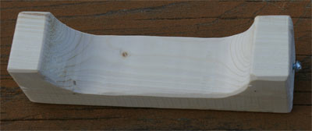

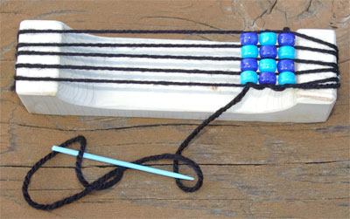

- The students can use four columns on the graph paper to simulate the loom. The students can use graph paper and pony beads to represent the loom as in the diagram or they can use graph paper and colored markers/pencil crayons.
- Have the students use two colors of pony beads or two colored markers to create a pattern of their own on the simulated loom. The following is the start of one such pattern:

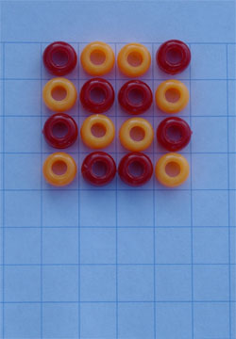

- Have the students continue their pattern for seven rows. When the pattern is complete, ask students: Without counting, how many beads are on your loom? How did you come to that answer?
- Have students come to the front and demonstrate how they came to that answer. Possibilities may include: 4 x 5 = 20, 4 x 2 = 8, 20 + 8 = 28
- Ask the students how many beads it would take to make nine rows and how they arrived at the answer.
- Reinforce the fact that this is a multiplication activity.
- Ask the students how many beads it would take to make one row. When the students respond that four beads are in one row, ask the students to explain the property for determining the answer when multiplying numbers by one.

